Leadership Considerations for 21st Century Veterinarians
Donald F. Smith, DVM, DACVS
Professor of Surgery and Dean Emeritus
Member, National Academy of Practices
Cornell University College of Veterinary Medicine

Dr. Tom Johnson acts like a man half his age. With a broad smile and emotive face that invites friendship and espouses sincerity, I met Tom in the faculty lounge at Iowa State University last November. A colleague, Julie Kumble, and I had been invited to Ames to give a lecture on women’s leadership. High on our agenda, however, was to interview the executive secretary of the Iowa State Veterinary Medical Association (IVMA) to learn how they had so successfully transformed their leadership profile over the preceding decade.

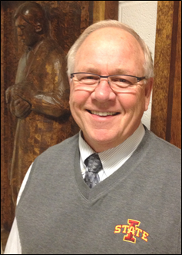
Tom Johnson, DVM (Iowa State U, 1971)
Executive Director, Iowa Vet Med Assoc
(Picture by Julie Kumble, 2013)

Anticipating our question even being asked ‘WHY’, Tom said, “If the profession is no longer old, grey-haired guys, then old grey-haired guys cannot be leading the profession.” He explained that the IVMA had recognized several years earlier that they needed young people in the organization and that, because of today’s demographics, that means they were going to be female.

Johnson then launched into a description of how the IVMA had encouraged, facilitated and mentored young veterinarians—women and men—to assume leadership roles in as early as their first few years after graduation. The changes went to the core of how their association did its business: how it set term limits to allow new members to be elected, how they shared leadership responsibilities so more people could be involved, how they supported young veterinarians financially so they could attend meetings, and how they partnered with Iowa State University to get students involved in leadership activities while they were still in college. To discover more about some of the changes they adopted, please refer to the following story, https://www.veritasdvmblog.com/veterinary-leadership-iowa/

The purpose of this invited article is to encourage leadership among the emerging generation of veterinarians. Most of the background work for sharing these comments and recommendations comes from my work in women’s leadership with Julie Kumble. We have focused our study on the four general areas: organized veterinary medicine, clinical practice, academia and industry; and since September 2012, we have interviewed over 40 leaders in these areas, including several men.

About a year into our research, and as a result of events at the House of Delegates (HOD) meeting during the AVMA convention in Chicago, we were invited to be among the founding members of the Women’s Veterinary Leadership Development Initiative (WVLDI). Since then, we and others from the organization have been invited to give several presentations on women’s leadership at national and regional meetings. Earlier this month, we hosted the first course for veterinary students at Cornell University, https://www.veritasdvmblog.com/veterinary-students-stepping-womens-leadership-training/

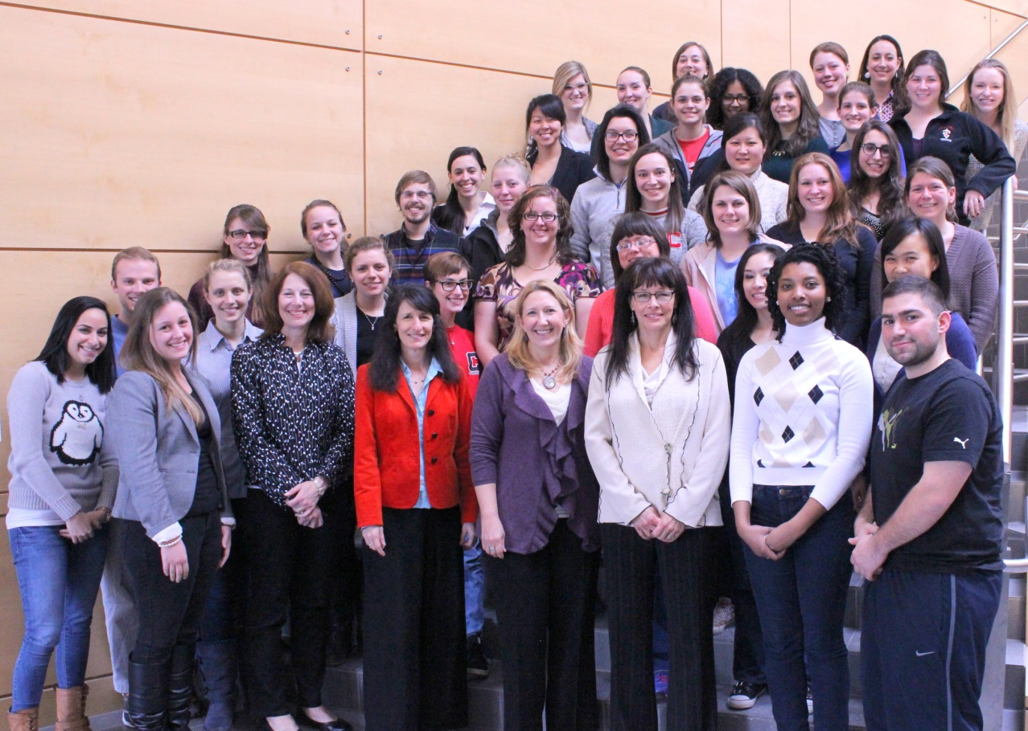
Students and instructors who participated in the first formal course for
Women’s Leadership in Veterinary Medicine, Cornell University, March 1, 2014
(Picture by the author, 2014)

Never in my experience spanning 40 years in veterinary medicine has a topic of importance to the profession developed so much momentum and involved so many interested people in so brief a period of time. There seems to have been a nascent interest in getting more women and young people into leadership, and the confluence of events at the national, state and regional levels has spawned an outpouring of dedicated energy that is spanning all facets of the profession. This interest is expressed by men as well as women.

Though women have been making their mark of the profession for about 80 years, it wasn’t until the mid 1970s that their presence began to be felt in significant numbers. For example, my class had just 13 women of eighty. A decade later, women broke the 50% barrier, and recently became over 50% of the entire profession. But the percentage of women in leadership positions has not kept pace, even remotely.

As Julie Kumble reminds us, we should not be surprised by this, because almost everywhere we look, from CEO’s of Fortune 500 companies, to the entertainment business, to the military, and even to the US Congress, the percentage or women is seldom higher than 20%. That’s where we are “stuck”, despite overwhelming evidence in the public, private, educational and corporate worlds that we need a minimum of 30% women to effect meaningful change in an organization or business. When women are present at this level in senior management or on boards, there is a greater likelihood that the policies and culture of a business organization will be more reflective of the work force and the clientele, and that profits will rise.

What has happened at highest level of veterinary medicine? The AVMA’s first woman president was installed in 1996. A year later, Drs. Bonnie Beaver and Joni Samuels were elected for six-year terms on the Executive Board. When Dr. Beaver became the second female president at the end of her executive board term, it was generally assumed that the momentum would build and the gender profile of AVMA leaders would become more representative of the membership. But a decade later, we have had just one additional woman president and, until this spring, not a single additional woman had been elected to fill a district position on the Executive Board.

Though more progress has been made at the House of Delegates where 30% voting delegates are women, the seven-member House Advisory Committee (which had a women, Dr. Karen Bradley, as chair between 2000-2013), is once again entirely male.

Karen Bradley, DVM, Co-owner Onion River Animal Hospital, Middlesex, VT
Member AVMA House of Delegates and Past Chair, House Advisory Committee
(Photo provided by the AVMA, 2013)

In our veterinary colleges, despite over three decades of exercising affirmative action policies, we have only six women deans (20%), and the last half dozen or so appointments have been male. That is not just embarrassing, it is appalling, and there appears to be no significant likelihood for that percentage to change significantly in the near future unless more innovative action is taken now. Amazingly, the aggregate of US veterinary colleges report having only 22% women among their tenured full professors as women.

What about industry, where some of the most progressive corporate policies have been put into place by companies such as Zoetis, Hill’s Pet Nutrition and CEVA Animal Health? Though the number of women at the very top is still small―Dr. Karen Padgett (Chief Operating Officer of CEVA) is an exception―real progress has been made in senior management positions. Success doesn’t just happen by itself, however. It takes the strong and unwavering commitment on the part of leaders like Padgett and Mr. Clint Lewis (Executive VP and President of US Operations of Zoetis) to catalyze change.

In this era of global communication, the transparency of information about leadership is critical. As the interest in gender becomes more important to employees and clients of private veterinary companies, especially those that have overwhelmingly large proportions of women in their employ, senior executives of private companies (who may not legally be required to disclose their board membership to their employees or the public) should reconsider whether the composition of their board membership become more transparent.

During our various interactions with veterinarians of both genders, we seldom encounter people who do not share the opinion that we should have more women leaders. However, the conversation often centers on the question of whether the high proportion of women will naturally lead to a more evenly -balanced cohort of leaders in the future―that is, let the natural course of events and replacement play out―or whether it is time to determine if there are systemic barriers and institutional policies that make it difficult for women to move upwards in the hierarchy.

Dr. Johnson and his colleagues at Iowa certainly feel that the profession’s leaders need to be proactive, citing his strong opinion that change will not occur on its own. The publication in 2013 of Sheryl Sandberg’s transformational book, “Lean In: Women, Work and the Will to Lead”, offers substantive evidence that the Iowans are right.

As recently as two years ago, I still felt that change would occur during the normal course of events as more and more women moved through the pipeline and gained leadership experience. In fact, I was so confident that policies such as affirmative action that are commonly deployed in my familiar ivory tower setting would effect change, that it took a very spirited discussion with Julie Kumble to make me reconsider my position. I realized that universities had not just failed in getting women into the most senior of positions, but they also were not encouraging and teaching veterinary students how to move into leadership positions early in their careers. It was an epiphany of sorts, and I realized that assertive, systemic change was critical, and that it would probably have to come from outside the academy. The timetable for tearing down some of the institutional barriers was now, not five years from now.

Gender differences between men and women are deeply rooted in stereotypes that are often misinterpreted and used to buttress the arguments that women’s leadership is going to be forever constrained. However, forward thinking veterinary programs are proving that to be wrong.

Success does not have to be abstract. It can be here and now. Here are a few examples of leadership emanating from Ms Kumble and my interviews with women veterinary leaders.

First, from academia, where Dr. Sheila Allen, dean at the University of Georgia, would probably not have progressed to senior administration as early in her career had it not been for the mentoring of Dr. Keith Prasse, who was her major professor during her graduate program. Allen had been complaining to Prasse about the lack of women leaders at Georgia and he finally just confronted her with the reality that she had the right personal and professional qualities to be associate dean which was open at the time. She did apply, and not only got the job, but so distinguished herself that she followed Prasse as dean. For those who worry that the time is not right because of family obligations, or perhaps they do not feel quite prepared for a major expansion of responsibilities, Allen’s story is worth reading, https://www.veritasdvmblog.com/dr-sheila-w-allen-university-georgia-veterinary-dean-passion-education/.

As Dean Allen showed, mentoring can be critical to success.

Elizabeth Newsom-Stewart is a second-year veterinary student at Cornell. She recently completed a course I teach in veterinary history and public policy and, for the course assignment, interviewed a veterinarian who had graduated just three years ago. Dr. Angela Silva has developed into an excellent clinician with superior people and business skills. After reading the student’s report, I asked Dr. Silva’s first boss what he considered the reason for Angela’s success. “Angela was a model new graduate,” he said, “enthusiastic, confident and willing to work hard. She identified me as a mentor, giving me no choice, and worked hard to ensure that I was as willing to give as she was to work (emphasis added).”

Another leader, Dr. Eleanor Green, was one of only three women in her class at Auburn. She has a multitude of “firsts” to her credit, including the first woman president of the American Association of Equine practitioners and the first women dean of veterinary medicine at Texas A&M University. Green attributes an important part of her success to an unrelenting drive to take formal classes in leadership training. Early in her career, she participated in an intensive, two-week cased-based leadership program at Harvard University. “I was the only veterinarian in the group,” she said, and then commented on veterinary medicine more broadly. “We enter the profession to be good clinicians, but we need to do more leadership training so young veterinarians can be better prepared to pursue career opportunities as they find themselves in positions where leadership skills would be important to their impact and success.” Read her entire story at, https://www.veritasdvmblog.com/texas-dean-eleanor-green-hall-fame-veterinarian/

Dr. Eva Evans is a 2012 graduate of the University of Tennessee. She practices in Nevada and in 2013 became the youngest member of the AVMA’s Political Action Committee. Her story is inspiring to young veterinarians, in particular. “I was blessed and fortunate to meet several amazing colleagues along the way; bosses, friends and mentors all helped guide me to the destination. The key to getting started is to express interest, and talk to anyone and everyone about what you want to do. You never know who you’ll meet, and those contacts can serve as advisors as well as advocates for you. These people will become lifelong friends, and one day you may have the opportunity to return the favor.”

Eva Evans, DVM (U Tenn, 2012)
(Picture by Dr. Evans, 2013)

Evans also tells young veterinarians not to be “afraid to put yourself out there,” to take risks and promote yourself. “Sometimes our lack of traditional experience can be a strength.” Read Dr. Evans’ personal story at, https://www.veritasdvmblog.com/path-leadership-new-dvm-story-dr-eva-evans/

The area of women’s leadership in private veterinary practice is a topic that should be explored in more detail than is possible here. In our interviews with women in practice, we have learned some of the fundamental keys to success in this age of perceived oversupply of veterinarians. Successful women have found ways to not just cope, but to own successful practices and deliver the kind of veterinary care to which they are committed, along with creating an atmosphere in their practice that meets the needs of the veterinarians and technical staff (most of whom are women) in their employ. Some of these success stories are described at www.veritasdvmblog.com.

The bottom line is that women and young people can step up and be counted to lead the profession alongside those of us who have had more years’ experience. You have skills, insight, energy and ambition that we need. Those of us who have had the opportunity to be leaders have a strong desire to mentor and guide you. We want to watch you soar and shape the profession that we are leaving for you. Through establishing yourselves as leaders while you are still young, you will gain the lateral vision to think about the future of veterinary medicine as a health profession for humankind as well as for animals.

I invite you to share comments with me at dfs6@cornell.edu, cell 607-279-9940. My website that has links to my blogs is at http://www.vet.cornell.edu/faculty/SmithD/

With acknowledgement and thanks to my colleague, Julie Kumble, for her participation in our joint research and writing. Special appreciation and thanks also to my friends and colleagues at the Women’s Veterinary Leadership Development Initiative, the directors (in addition to Julie and myself) being: Drs. Karen Bradley (president), Stacy Pritt (vice-president), Douglas Aspros (Sec-Treas), Rachel Cezar, Eleanor Green, Valerie Ragan, Beth Sabin, Lori Teller, and veterinary student, Cassandra Tansey.

Julie Kumble, Interim CEO, Women’s Fund of Western Massachusetts
https://www.veritasdvmblog.com/five-days-in-july-catalyzing-a-new-wave-of-womens-leadership-in-the-avma/
Women’s Leadership Development Initiative. http://www.womenveterinarians.org/
This story and quote is from the interview and report by Elizabeth Newsom-Stewart, Cornell DVM student, Class of 2016.

