Diversity and Inclusion in the Veterinary Profession
Emerging Leaders Networking Event; January 8, 2015
AVMA Veterinary Leadership Conference

Facilitator: Dr. Beth Sabin
AVMA Associate Director, International & Diversity Initiatives

AVMA Diversity Policy

The AVMA is committed to diversity and inclusion in all aspects of the profession of veterinary medicine so that we can best serve the animals, the public and our members. Our goal is to mirror the growing diversity of the communities we serve and to promote an understanding of their varied needs. To this end, we are committed to actively promoting and maintaining diversity in our membership and organization, and educating our members regarding the value of diversity. This commitment embraces the value of the many areas of the veterinary medical profession, and the value of our members’ varied cultural backgrounds, ethnicities, genders, sexual orientations, ages, religions, physical and mental abilities, and racial representations. (First adopted 2004; revisions approved 2012)

*****************************************************************************
AVMA Reports

- Unity through Diversity: Final Report of the AVMA Task Force on Diversity (2006)
  - www.avma.org/KB/Resources/Reports/Documents/diversity_report.pdf
- 20/20 Vision Commission Report (2011)
  - www.avma.org/KB/Resources/Reports/Pages/AVMA-2020-Vision-Commission-Report.aspx
- AVMA Strategic Plan: 2012-2015 (2011)
  - www.avma.org/About/Governance/StrategicPlanning/Documents/strategic_plan_2012-2015.pdf
- US Veterinary Workforce Study: Modeling Capacity Utilization (2013)
  - www.avma.org/KB/Resources/Reports/Documents/Veterinarian-Workforce-Final-Report-LowRes.pdf

*****************************************************************************
The AVMA wants your input…

…The D&I area of the AVMA Web site (www.avma.org/diversity) is a work in progress and collegial member input can be sent to esabin@avma.org (800-248-2862, ext 6711).

…Join the conversation on LinkedIn and share your story and thoughts— www.linkedin.com/groups/Access-Opportunity-in-Veterinary-Medicine-6500831/about

*****************************************************************************

AVMA Partnerships & Collaborations

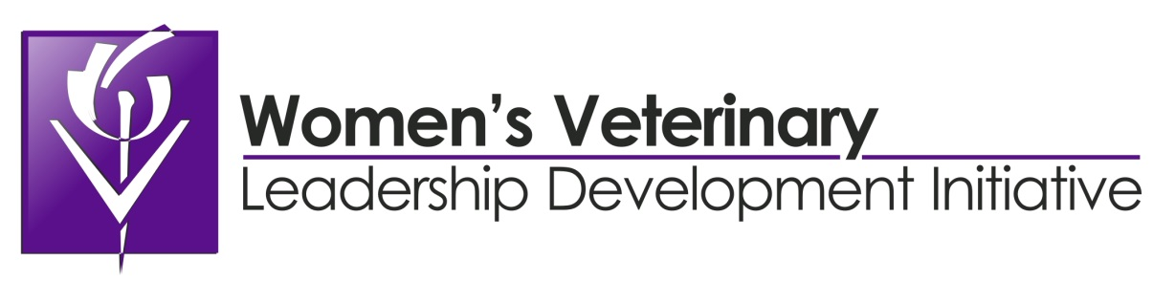
www.womenveterinarians.org

- Vision—To develop leaders for the benefit of the profession and to deliver on the promise of veterinary medicine to society.
- Mission—To support women in seeking and achieving leadership, policy, and decision-making positions within all areas of professional veterinary activity.

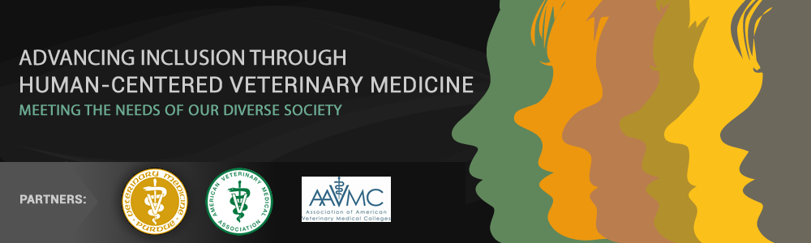
www.humancenteredvetmed.org

Center of Excellence for Diversity and Inclusion in Veterinary Medicine
At the Center of Excellence for Diversity and Inclusion in Veterinary Medicine we envision an inclusive veterinary profession that is prepared to meet the needs of our increasingly diverse society. We believe that establishing a veterinary workforce where all individuals are inspired, supported, and empowered to achieve their full potential, will lead to breakthroughs in animal and public health.

What is Human-Centered Veterinary Medicine?
Human-Centered Veterinary Medicine recognizes that a veterinarian’s relationship with an animal’s caretaker is a crucial factor in optimizing that animal’s health and wellbeing. Center goals will focus on providing resources that increase intercultural competencies of veterinary professionals and lead to inclusive workplaces that are welcoming for both professionals and clients.

Online Certificate Programs for Diversity and Inclusion in Veterinary Medicine
Are you prepared to meet the needs of our increasingly diverse society? Purdue University, through the Center of Excellence for Diversity and Inclusion in Veterinary Medicine, presents online professional certification programs designed for veterinarians, veterinary technicians, educators, students, and staff who seek to improve their communication, leadership, teaching/learning, and cultural competency skills. Help change the face of veterinary medicine by contributing to inclusive work and learning environments where everyone can reach their full potential.

